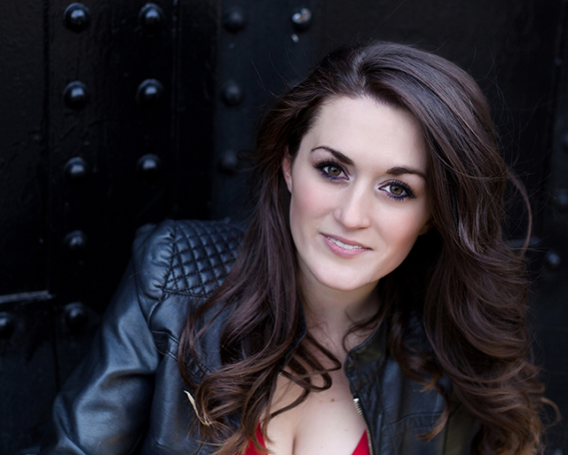
BRONWYN WHITTLE

Phone: 646-808-5025 Height: 5’4”
Email: Bronwyn.Whittle@gmail.com Voice Part: Mezzo/Soprano

NYC and Off- Broadway:
Annie Warbucks Sheila Kelly The Signature Theatre
Madame Infamy (NYMF) Martha Jefferson The Signature Theatre
The Butterfly Girl Tour Guide Vital Theater
The Cave: A Folk Opera Leila/ Ondine Access Theatre

National Tour:
Broadway Christmas Wonderland Vocal Soloist Spirit Productions
Dublin’s Irish Tenors and the Celtic Ladies Vocal soloist Dublin Worldwide Productions

Regional Theatre:
Ellis Island: Gateway to a Dream Francie O’Ryan Sundog Theatre Company
-Dir. David Leidholt
Carrie: The Musical Miss Gardner Peregrine Theatre Ensemble
The Parade Wanda Tennessee Williams Festival
-Dir. Jeff Hall-Flavin
Commercials:
The Mind Jack Trailer Beth Spitalny Project
Philadelphia Cream Cheese Buzzfeed Uk

Training and Education: BA in Theatre- Wagner College NY
Acting- John Jamiel, David McDonald, Michael Tennenbaum, Naomi Ballis, Kathryn Coffey
Musical Theatre-Michele Pawk, Drew Scott Harris, Gina Fiore, Lauri Young
Dance- Debbie Young (Ballet), Cecilia Flores (Modern), Rusty Curcio (Movement)
Voice- Alan Dornak (Current)

Special Skills
Dialects (Irish, Southern, British); Whistle Tone; Moderate piano and guitar skills; Knitting; Speaking with mouth closed.

